Work plan 9e OZAK 2026

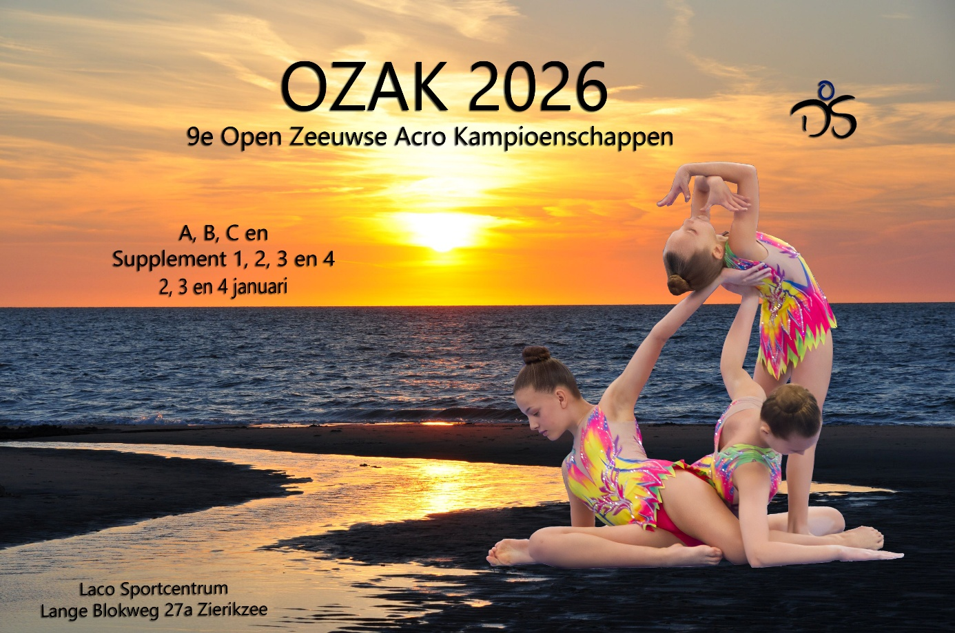

General Information
On January 2, 3, and 4, 2026, we will organize our 9th OZAK.
OZAK stands for Open Zeeuwse Acro Championships. As of this season, the regulations for recreational acrogym have been updated. At our tournament, Supplement levels 4, 3, 2, and 1, as well as the ABC levels, are welcome.
In recent years, various clubs from Belgium and Germany have participated, and we hope to once again welcome several international teams this year.
We are pleased to offer gymnasts the opportunity to compete with others, especially at the beginning of the season. Our main goal is to let every participant shine at their own level. For the youngest athletes, it is a great opportunity to show their routine for the first time in a relaxed environment.
The competition schedule and daily timetables are not yet finalized, as they depend on the number of entries per level. After registration closes, the schedule will be announced as soon as possible in AcroCompanion.

AcroCompanion
Just like last year, competition registration will take place via AcroCompanion. Through this platform, you can view the competition order, jury assignments, and live scoring. Please note that there will be no separate communication outside this system. Make sure your club has valid login credentials before registration.

Ages / Supplements / Levels / Disciplines
During the OZAK, the categories and age divisions of the KNGU (Dutch gymnastics federation) will apply. The starting age is this minimum age of the top.
2.1 ABC levels
C-Junior: 9–17 years
C-Senior: 9+
B-Junior: 10–19 years
B-Senior: 10+
A-Pupil: 8–15 years
Pre-Youth: 9–16 years
Youth: 10–18 years
Junior: 11–20 years
Senior: 12+
2.2 recreational levels
Age | Supplement 4 | Supplement 3 | Supplement 2 | Supplement 1
Pupil  7 t/m 12 jr | X
Youth  8 t/m 14 jr | X | X | X
Junior  9 t/m 16 jr | X | X | X | X
Senior  vanaf 9 jr | X | X | X | X
- In Supplement 4, only the disciplines pair and trio are allowed.
- In Supplements 3, 2, and 1, gymnasts may compete in all three disciplines: pair, trio, and groups of four.

Payment of Entry Fees
Fees are calculated per routine:
1 routine – €20 per athlete
2 routines – €25 per athlete
3 routines – €30 per athlete
Invoices will be created and sent via AcroCompanion. Payments should be made to:
IBAN: NL83 RABO 0150 1026 66
Reference: GV Deltasport OZAK 2026 + Club Name
Please ensure payment is completed by November 20, 2025. Registration is final once payment has been received.
Entry fees are based on the registration status as of November 6, 2025, and the registered level. If a team withdraws or reduces the number of routines afterwards, fees must still be paid in full. Payments must be made per club — not per athlete or team.

Schedule – 9th OZAK
The warm-up and competition floor entry times will be published in AcroCompanion. There will be no block warm-up; a warm-up floor and a sprung floor will be available in the warm-up area. Each team may use the sprung floor for a maximum of 30 minutes.
The competition will start on Friday at 13:00. On Friday and Saturday, there will also be evening sessions. The aim is to finish on Sunday by 16:00.
We strive to structure the event progressively by level, starting with recreational levels on Friday and concluding with the ABC levels on Sunday. However, this may depend on the number of entries per level, and no guarantees can be made.

Venue and Contact Information
Venue:
Laco Sportcentrum
Lange Blokweg 27A
4301 NW Zierikzee, The Netherlands
Tel: +31 (0)111 413 690
General Contact:
Name: Toos Huijzen
Phone: +31 6 83656480
Email: ozak@deltasportgym.nl
Website: www.deltasportgym.nl
AcroCompanion Contact:
Name: Stef van der Locht
Phone: +31 6 46304960
Email: ozak@deltasportgym.nl
Music Contact:
Name: Wendy Huijzen
Phone: +31 6 30521717
Email: ozak@deltasportgym.nl
Competition Sheets Contact:
Name: Brigitta Jansens
Phone: +31 6 43827290
Email: ozak@deltasportgym.nl
Please direct all correspondence by email. For urgent matters, you may call or send a WhatsApp message.

Competition Program
6.1 ABC Competition:
- FIG levels perform three routines: balance, dynamic, and combined.
- Pre-Youth teams perform two routines: balance and dynamic.
- Pupil teams perform a combined routine.
- B and C levels perform balance and dynamic routines.
6.2 Recreational Competition (Supplements):
- Supplements 4, 3, and 2 perform a combined routine.
- Supplement 1 teams perform balance and tempo routines.
The total number of points determines the final ranking. In case of a tie, the ranking is based on the total score of one or two routines.
6.3 Special Awards
- An additional award will be presented for clubs from Zeeland — the Zeeland Championship 2026.
- Each day, a trophy will be awarded for the highest routine score of the day.

Judges
Each participating club is required to provide judges. For every six participating teams, one judge with at least AC2 certification (for Supplements 4, 3, 2, 1) must be registered. For Sunday, judges must hold at least AC3 certification.
Each club must provide one judge per competition day on which it has teams participating.
Failure to meet this requirement will result in a €250.00 fine per missing judge. We sincerely hope this measure will not be necessary.
The list of judges will be published via AcroCompanion no later than December 15. Head Judges and Main Judges will receive a personal invitation by email.

Regulations
The competition will adhere to the KNGU regulations, which can be found on the Dutch Gymnastics website.

Competition Sheets and Music
9.1 Competition Sheets
Competition sheets cannot be created within AcroCompanion and must be prepared independently. They must be submitted as a PDF via AcroCompanion no later than December 17, 2025 (early submission due to the holiday season).
9.2 Music
Music must be uploaded in AcroCompanion no later than 24 hours before the competition.

Recommendations
Since our beautiful Zierikzee may be a long trip for some participants, we recommend booking accommodations in a hotel, B&B, or holiday park. There are many available options — please book early to avoid disappointment.
Our Recommendations Include:
- https://www.zeeuwsestromen.nl/
- https://hectorzierikzee.nl/
- https://stelle.nl/kampeerboerderij/ – Chalet for 10 persons
- https://mondragon.nl/
- https://www.zeeuws-meisje.nl/
- https://vanoppenhotel.nl/
- https://www.dezeeuwsehemel.nl/
- https://www.slapenbijklaasvaak.nl/
- https://hotelwaterstate.nl/
- https://www.groepsaccommodatiegerner.nl/
- https://www.bungalowparkoverzicht.nl/vakantieparken/schouwen-duiveland/
- https://www.fletcherstrandhotelrenesse.nl/

